Technical Report

for

SMART SEPTIC TANK MONITORING SYSTEM

Prepared by

Group Name: CS19/14

|  |  |  |  |
| --- | --- | --- | --- |
| REG NO | STUDENT NO | FIRST NAME | LAST NAME |
| 17/U/427 | 217001045 | KITALE | DOREEN |
| 17/U/20656/EVE | 217022061 | WATKIDOG | JOACHIM |
| 17/U/5678/PS | 217002578 | LOCHA | DERRICK |
| 17/U/9492/PS | 217002922 | ODONG | NICHOLAS |

|  |  |
| --- | --- |
| Mentor: | Prof. Engineer Bainomugisha |
| Course: | CSC 1304 Practical Skills Development |
| Date: | 29/07/2019 |

TABLE OF CONTENTS

CONTENTS …………………………………………………………………………………….. 2

ABSTRACT …………………………………………………………………………………….. 3

1. INTRODUCTION ………………………………………………………………………….. 4
   1. USER CHALLENGES ……………………………………………………………... 4
   2. PROJECT GOALS ………………………………………………………………..... 5
   3. FUCTIONAL REQUIREMENTS ………………………………………………….. 5
   4. NON FUNCTIONAL REQUIREMENTS ………………………………………..... 5
2. PROJECT RESULTS ……………………………………………………………………..... 6
   1. PROJECT DESIGN ………………………………………………………………… 6
   2. PROJECT FUNCTIONALITY AND SCREENSHOTS …………………………… 7
3. LIMITATIONS AND NEXT STEPS ……………………………………………………… 10
   1. LIMITATIONS …………………………………………………………………..... 10
   2. NEXT STEPS ……………………………………………………………………... 10

REFERENCES …………………………………………………………………………………. 11

APPENDIX A: PROJECT WORK-PLAN …………………………………………………….. 12

APPENDIX B: CONTRIBUTION BY TEAM MEMBERS ………………………………….. 13

**ABSTRACT**

With the rapid developments happening around Uganda, many people are transitioning from the traditional pit latrines to modern toilets, which are either connected to the public sewerage system, or to a septic tank system. This project focuses on the septic tank system.

A septic tank is an underground wastewater treatment structure made of concrete, fiberglass, or plastic through which domestic wastewater (sewage) flows for basic treatment. They use a combination of nature and proven technology to treat wastewater from household plumbing produced by bathrooms, kitchen drains, and laundry. Waste that is not decomposed must eventually be removed from the septic tank in time. Otherwise the septic tank fills up and wastewater containing undecomposed material discharges directly to the drainage field. This is detrimental to the environment; causes bad smell, diseases, and the system itself clogs, thus requiring expensive repairs.

This project (A Smart Septic Tank Monitoring System), is meant to solve this problem. This system is to be installed within the septic tank to monitor the level of waste in the tank. The system makes use of an ultrasonic sensor [1] that uses sound waves to keep track of the current level of waste, and a GSM module [2] to send updates to the concerned individuals when the septic tank is almost and when full, to prevent issues of overflow and discomfort to the environment.

1. **INTRODUCTION**

The purpose of this document is to describe the features and functionality of the Smart Septic Tank Monitoring System. The document is divided into four main sections, which include: the introduction, project results, limitations and next steps, and the appendix.

The introduction explains the problem being solved and its relevance, the goal of the project and the project’s requirements. In the project results, we describe the system architecture and design; product functionality with relevant screenshots, and a link to the public project repo on GitHub. The third section describes the limitations, and next step for the project. In the appendix, we have included the project work-plan and contributions of each group member.

**1.1. USER CHALLENGES**

Today, most homes use septic tanks as their drainage for wastewater and sewage from their homes, but monitoring the level of waste in these tanks can be challenging since they are installed underground and require some level of expertise [3]. The septic tanks therefore usually fill-up and end up overflowing leading to bad smell and inconvenience in the environment. In areas with poor drainage systems, in case of heavy rains, the wastes end up in peoples’ house and on the roads leading to diseases like cholera and typhoid.

There are three main reasons why smart septic tank monitoring system is so important:

1. Money - Poor maintenance is a common cause of early system failure. The minimal amount of preventive maintenance a septic system requires costs very little compared to the cost of repair and replacement.
2. Health - When a septic system over fills, inadequately treated household wastewater is released into the environment. Direct contact with poorly treated human waste can pose significant health risks. Untreated wastewater can also contaminate nearby ground and surface water.
3. Economic Health of Community - Failed septic systems lower property values and contribute to the pollution of local rivers, lakes, and ponds used for commercial or recreational activities.

**1.2. PROJECT GOALS**

**Main Goal**

To develop a Smart Septic Tank Monitoring System, that will be used to track the level of waste in the septic tank, and prevent overflow.

**Specific Objectives**

* To analyze the current septic tank monitoring systems and determine their weaknesses.
* To design a more convenient and flexible septic tank monitoring system.
* To implement the system.
* To test and validate the system.
  1. **FUNCTIONAL REQUIREMENTS**

1. The system must be able to measure the level of waste in the septic tank at all times.
2. The system must send data collected from the septic tank to the server.
3. The system must send a waning message when the septic tank is almost full i.e. when it has reaches 80% of the tank.
4. The system must send the last message when the septic tank has reached 95% i.e. considered to be full.
5. The system must shut down after sending the last message.
   1. **NON FUNCTIONAL REQUIREMENTS**
6. The system is portable. It can easily be transported from one place to another, especially when the customer is in a remote place.
7. The system is scalable, i.e. can easily be modified.
8. The system is easy to use and does not require regular maintenance.
9. Response - The user is able to receive the messages indicating the status of the septic tank.
10. **PROJECT RESULTS**
    1. **PROJECT DESIGN**

**The Architectural Diagram**

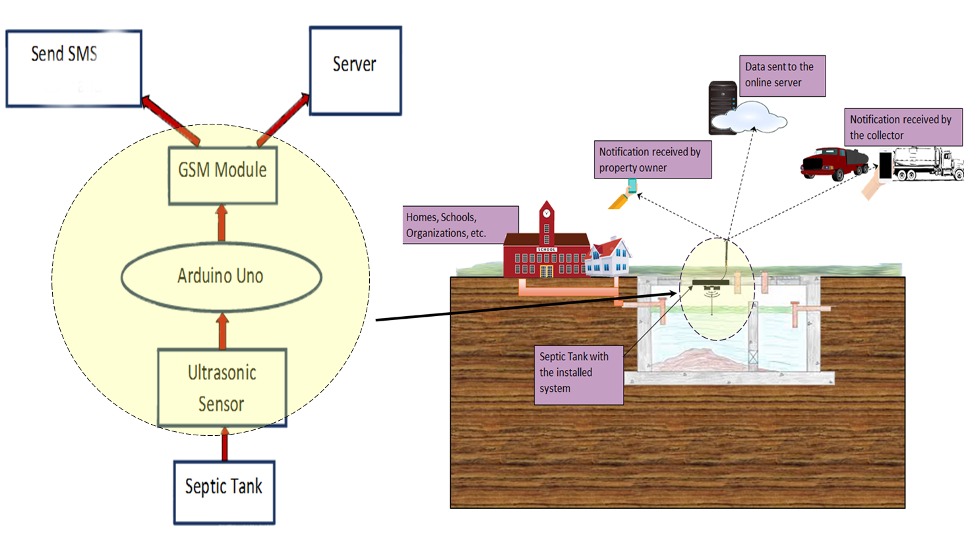

**The Data flow Diagram**

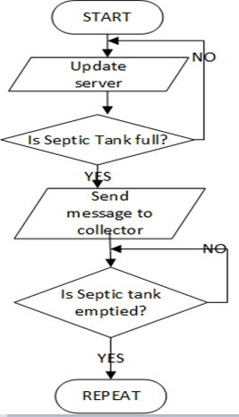

* 1. **PROJECT FUNCTIONALITY AND SCREENSHOTS**

**The General project layout**

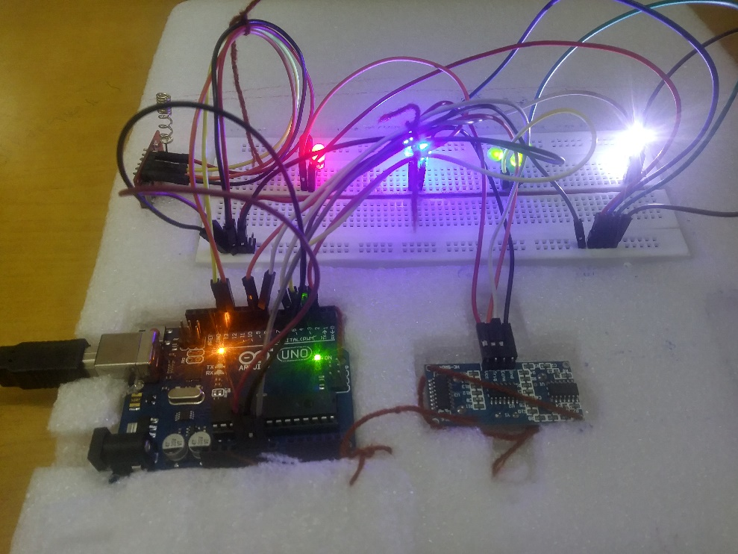

**The Ultrasonic sensor**

It measures the level of waste in the septic tank by transmitting sound waves of low frequency (40Hz), which are reflected back from the bottom of the septic tank to indicate the distance from the waste and top of the tank.

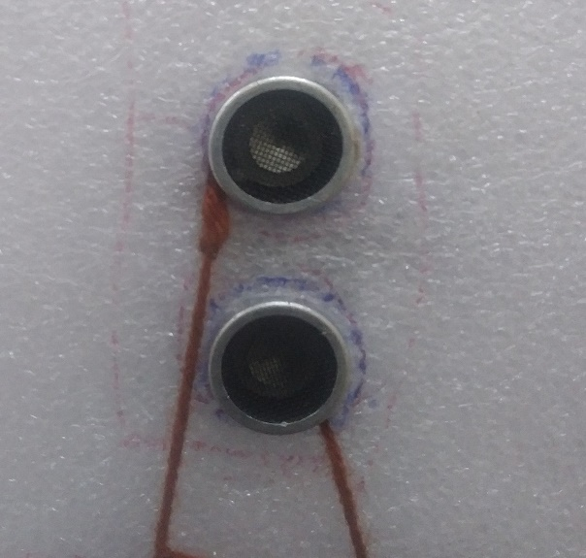

**The GSM module**

The GSM module is used for sending messages to the specified mobile contact, and also to send data to the ThinkSpeak server.

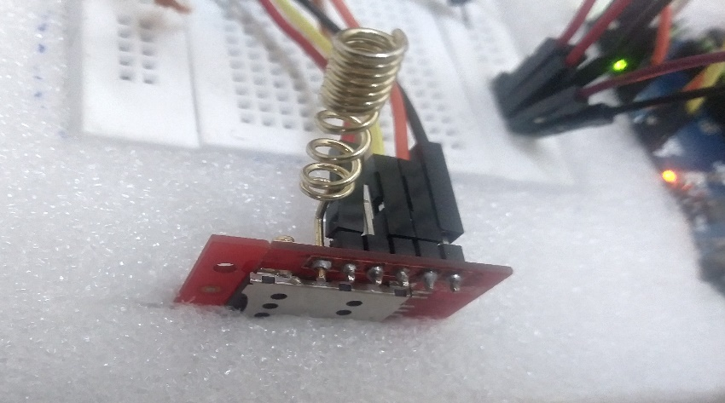

**Data at the ThinkSpeak server**

The graph below shows how the distance in the septic tank reduces as it gets filled up. It is used to provide a more user-friendly interface.

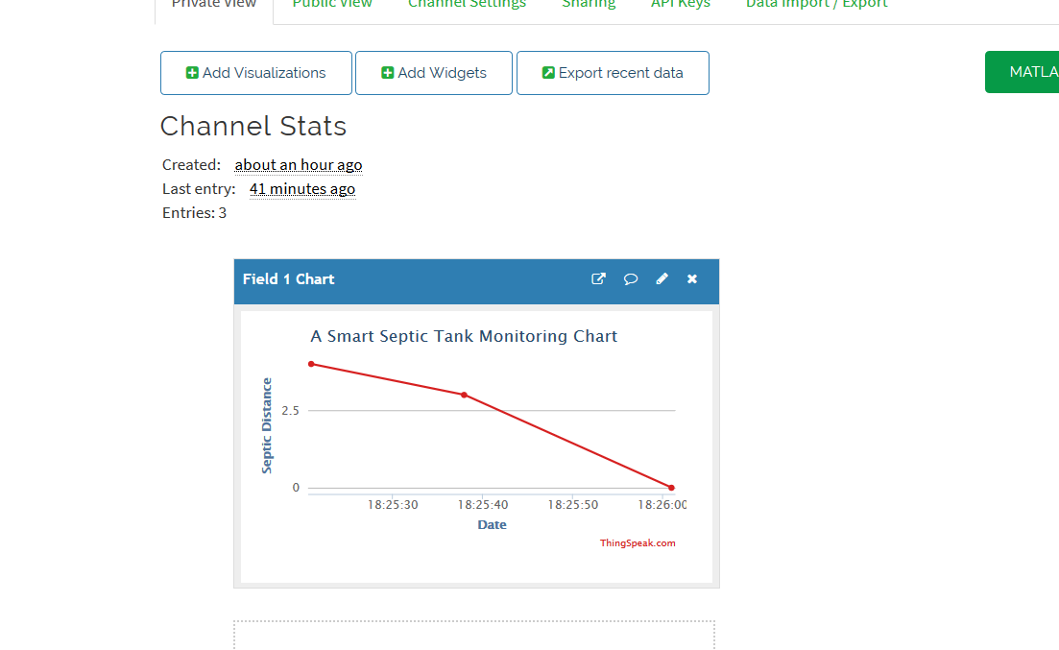

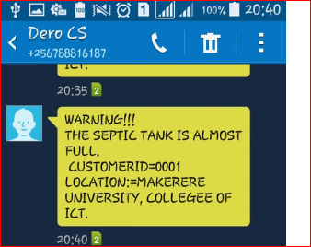**Warning and last messages received on user’s phone**

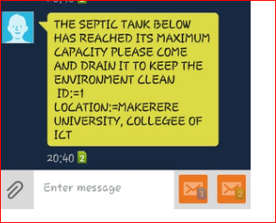

Last Message

Warning Message

* 1. **PROJECT WEBSITE AND REPOSITORY**

You can find out more about our project on GitHub at <https://github.com/cs19-group-14> - The link also contains the Website.

1. **LIMITATIONS AND NEXT STEPS**
   1. **LIMITATIONS**
2. Weak network for the Global System for Mobile (GSM), communication, which could be a problem when the system is installed inside the Septic tank. This can be solved by using stronger antennas, which can be mounted above the surface of the ground over the septic tank.
3. The ultrasonic sensor is not designed for underwater use, and therefore in case of an overflow, the system will seize to function and could possibly be damaged. This will require installation at a position that cannot be reached by the waste, and placing it within a water tight container.
   1. **NEXT STEPS**
4. For more efficiency and usability, we plan on building a mobile application through which the performance of the system can be monitored. This will eliminate the need for sending warning messages; the application will provide a more user friendly, graphical view of the system.
5. For powering the system, we shall opt rechargeable batteries powered by solar panels, since it is less expensive as compared to using non rechargeable batteries.
6. We also plan to monetize the system by rolling it out to potential customers like schools, hospitals, and large organizations that are not connected to the public sewerage system and therefore make use of septic tanks for their waste.

**REFERNCES**

[1] Deepiga, T, Sivasankari A, “Smart Water Monitoring System Using Wireless Sensor Network at Home/Office”, International Research Journal of Engineering and Technology (IRJET), vol. 02, no. 04, July-2015.

[2] Anap SD , Dengale Rani V, Ghule Suvarna U , Jadhav Shradha B, “ Wireless Based Water Level Monitoring and Control System of Electronics”, International Advanced Research Journal in Science, Engineering and Technology, vol. 3, Issue 4, April 2016.

[3] Water Technology Engineering LTD. “Septic Tank Problems and Septic Tank Solutions” <https://www.wte-ltd.co.uk/septictank.html>

**APPENDIX A – PROJECT WORK-PLAN**

The structure below shows the work plan that was followed to realize the Smart Septic Tank Monitoring system.

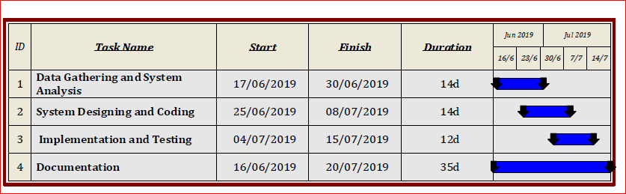

**APPENDIX B – CONTRIBUTION BY TEAM MEMBERS**

The following table summarizes each group member’s input to the project.

|  |  |  |
| --- | --- | --- |
| **No.** | **Team Member** | **Contribution** |
| 1. | LOCHA DERRICK | * General program code. * Code for sending data to the server. * Poster design. |
| 2. | WATKIDOG JOACHIM | * Code for sending a warning message when the septic tank is almost full and when it’s actually full. * Building the project website. * Creation of the GitHub repo. |
| 3. | KITALE DOREEN | * Code for Visualisation of what is happening in the septic tank. (Using the LEDs) * Writing the report. |
| 4. | ODONG NICHOLAS | * Interviewed the target customers for the system. * Group mobilisation. |